**Topics: Confidence Intervals**

1. For each of the following statements, indicate whether it is True/False. If false, explain why.
2. The sample size of the survey should at least be a fixed percentage of the population size in order to produce representative results.

**False:** The statement is false.

**Explanation**: The sample size in a survey does not need to be a fixed percentage of the population size to produce representative results. The appropriate sample size depends on various factors such as the desired level of confidence, margin of error, heterogeneity of the population, and the survey methodology being used (e.g., random sampling, stratified sampling). A

1. The sampling frame is a list of every item that appears in a survey sample, including those that did not respond to questions.

**False**: The statement is false.

**Explanation:** The sampling frame is a list of all the elements or units from which a sample is drawn. It should ideally cover the entire population being studied and be exhaustive, but it typically does not include those who did not respond to questions. The sampling frame serves as the basis for selecting a representative sample from the population.

1. Larger surveys convey a more accurate impression of the population than smaller surveys.

**True**

1. *PC Magazine* asked all of its readers to participate in a survey of their satisfaction with different brands of electronics. In the 2004 survey, which was included in an issue of the magazine that year, more than 9000 readers rated the products on a scale from 1 to 10. The magazine reported that the average rating assigned by 225 readers to a Kodak compact digital camera was 7.5. For this product, identify the following:
2. **The population:**

The population consists of all readers of PC Magazine who were asked to participate in the survey, specifically those interested in providing feedback on different brands of electronics.

1. **The parameter of interest:**

The parameter of interest is the true average rating that all readers of PC Magazine would give to the Kodak compact digital camera, if they were all surveyed.

1. **The sampling frame:**

The sampling frame is all the readers of PC Magazine who were asked to participate in the survey. It's important to note that not all readers may have participated, so the sampling frame is a subset of the total readership.

1. **The sample size:**

The sample size is 225 readers who rated the Kodak compact digital camera.

1. **The sampling design:**

The survey used a voluntary response sampling design, where readers were invited to participate and rate the products on a scale from 1 to 10. This type of sampling can introduce bias as it only includes individuals who choose to respond, and their opinions might not represent the entire readership accurately.

1. **Any potential sources of bias or other problems with the survey or sample:**

**Voluntary Response Bias:** Since participation in the survey is voluntary, individuals with particularly strong opinions (positive or negative) may be more inclined to participate, leading to a biased sample.

**Self-Selection Bias:** People who choose to respond to the survey may have different opinions compared to those who chose not to respond, introducing bias.

**Sampling Bias:** The sample is taken only from readers of PC Magazine,

which might not represent the broader population's opinions accurately,

especially those who don't read the magazine.

**Rating Scale Bias:** The scale of 1 to 10 used for rating may not be uniformly interpreted by all participants, leading to potential variations in the responses.

1. For each of the following statements, indicate whether it is True/False. If false, explain why.
2. If the 95% confidence interval for the average purchase of customers at a department store is $50 to $110, then $100 is a plausible value for the population mean at this level of confidence.

**True:**

If the 95% confidence interval for the average purchase of customers at a department store is $50 to $110, then any value within this range is a plausible value for the population mean at the 95% confidence level. In this case, $100 falls within the range and is a plausible value for the population mean.

1. If the 95% confidence interval for the number of moviegoers who purchase concessions is 30% to 45%, this means that fewer than half of all moviegoers purchase concessions.

**False:**

A 95% confidence interval of 30% to 45% for the number of moviegoers who purchase concessions does not mean that fewer than half of all moviegoers purchase concessions. The 95% confidence interval provides a range of estimates, and it is possible that half or more of the moviegoers purchase concessions as 45% is included in this interval.

1. The 95% Confidence-Interval for *μ* only applies if the sample data are nearly normally distributed.

**False:**

The central limit theorem states that for a sufficiently large sample size, the sampling distribution of the sample mean will be approximately normally distributed regardless of the distribution of the population, assuming the sample is taken randomly. Therefore, the 95% confidence interval for the population mean can be applied even if the sample data are not exactly normally distributed, especially if the sample size is large (e.g., n > 30).

1. What are the chances that 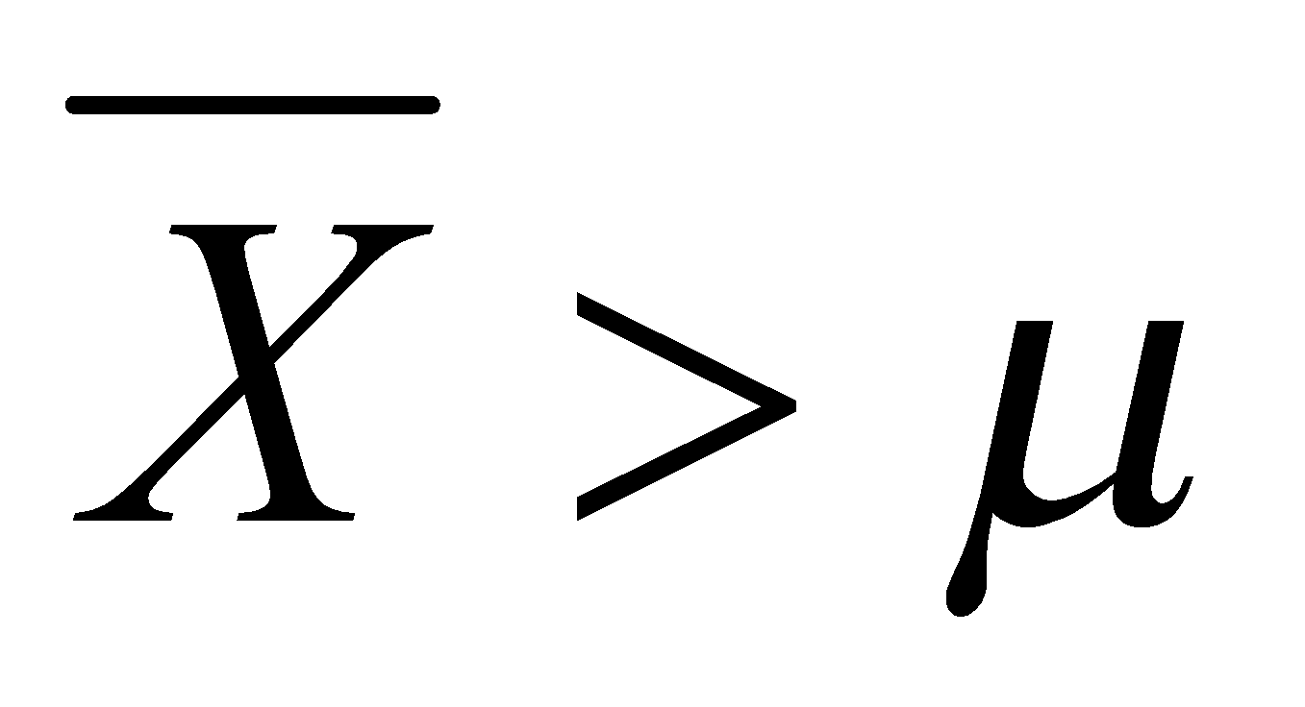?
2. ¼
3. **½**
4. ¾
5. 1

**Ans:** B. 1/2

1. In January 2005, a company that monitors Internet traffic (WebSideStory) reported that its sampling revealed that the Mozilla Firefox browser launched in 2004 had grabbed a 4.6% share of the market.
2. If the sample were based on 2,000 users, could Microsoft conclude that Mozilla has a less than 5% share of the market?

**Yes:** If the sample is based on 2,000 users and 4.6% of them use Mozilla Firefox, then this is less than 5%. Microsoft could conclude that, based on this sample, Mozilla has a less than 5% share of the market.

1. WebSideStory claims that its sample includes all the daily Internet users. If that’s the case, then can Microsoft conclude that Mozilla has a less than 5% share of the market?

**No:** Even if WebSideStory claims that its sample includes all the daily Internet users, a 4.6% share found in their sample does not allow Microsoft to conclude that Mozilla has a less than 5% share of the market for all Internet users. The sample might not perfectly represent the entire population of Internet users, and there could be factors leading to the discrepancy between the sample result and the broader population's actual share of Mozilla Firefox users. A more comprehensive study and analysis would be needed to draw such a conclusion with confidence.

1. A book publisher monitors the size of shipments of its textbooks to university bookstores. For a sample of texts used at various schools, the 95% confidence interval for the size of the shipment was 250 ± 45 books. Which, if any, of the following interpretations of this interval are correct?
2. All shipments are between 205 and 295 books.

**False:** This interpretation is incorrect. The 95% confidence interval (250 ± 45 books) does not mean that all shipments fall within this range. It's an estimate for the population mean.

1. 95% of shipments are between 205 and 295 books.

**False:** This interpretation is incorrect. The 95% confidence interval is an estimate for the population mean, not a statement about the distribution of individual shipments.

1. The procedure that produced this interval generates ranges that hold the population mean for 95% of samples.

**True:** This interpretation is correct. The 95% confidence interval is constructed in a way that, if you were to repeat the sampling process and construct intervals in the same manner, 95% of those intervals would capture the true population mean.

1. If we get another sample, then we can be 95% sure that the mean of this second sample is between 205 and 295.

**True:** This interpretation is correct. If you were to take another sample and construct a 95% confidence interval, you would expect the population mean to fall within that interval 95% of the time.

1. We can be 95% confident that the range 160 to 340 holds the population mean.

**True:** This interpretation is correct. While the original 95% confidence interval is 205 to 295 books, the population mean is expected to be within a wider range (160 to 340 books) with 95% confidence. This wider range reflects the uncertainty associated with the sample estimate.

1. Which is shorter: a 95% *z*-interval or a 95% *t*-interval for *μ* if we know that σ =s?
2. **The z-interval is shorter**
3. The t-interval is shorter
4. Both are equal
5. We cannot say

**Ans: A.** The z-interval is shorter

Questions 8 and 9 are based on the following: To prepare a report on the economy, analysts need to estimate the percentage of businesses that plan to hire additional employees in the next 60 days.

1. How many randomly selected employers (minimum number) must we contact in order to guarantee a margin of error of no more than 4% (at 95% confidence)?
2. **600**
3. 400
4. 550
5. 1000

Ans: **A**. 600

1. Suppose we want the above margin of error to be based on a 98% confidence level. What sample size (minimum) must we now use?
2. 1000
3. 757
4. **848**
5. 543

Ans: **C.** 848